**Project Title: IoT Based Safety Gadget for Child Safety Monitoring & Notification Project Design Phase-I** - **Solution Fit Team ID:** PNT2022TMID44152

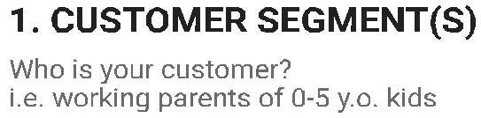

Availability of different models according to customer requirements

Solar charging

Concealed placement of the device

Budget

Tampering

Internet connectivity

Electricity stability

Hardware durability

Home-makers

Working Parents

Pre-school

Fun-zones/parks

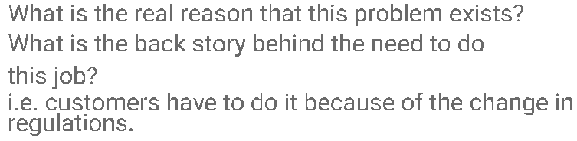

Safeguarding the child from harm

Tracking the temperature

Tracking heartbeat

Track the current location

Informing authorities in case of more serious crises

Raising alarms in instances of emergencies

Concerns regarding overall safety of minors

Increasing fear among parents about actions of children

Need to monitor kids constantly

Wearable GPS tracker that helps monitor the location of children in real-time

GPS-based alarm capable of sounding alert



**3. TRIGGERS TR**

Whattriggerscustomerstoact?i.e.seeingtheirneighbourinstalling solarpanels,readingaboutamoreefﬁcientsolutioninthenews.

Increasing events of kidnapping in recent news

A child who hasn’t grown well enough to be ensure safety of self

**10. YOUR SOLUTION SL**

Ifyouareworkingonanexistingbusiness,writedownyourcurrentsolutionﬁrst, ﬁllinthecanvas,andcheckhowmuchitﬁtsreality.

Designing a gadget for protecting the kids and alerting the parents in emergency situations

Ifyouareworkingonanewbusinessproposition,thenkeepitblankuntilyouﬁllin thecanvasandcomeupwithasolutionthatﬁtswithincustomerlimitations, solvesaproblemandmatchescustomerbehaviour.

**8.CHANNELS of BEHAVIOUR CH**

**8.1 ONLINE**

Online: Apps and add-ons can be developed to track the live location of children

Offline: Sensors and other detectors can be developed

Whatkindofactionsdocustomerstakeonline?Extractonlinechannelsfrom#7

**8.2 OFFLINE**

Whatkindofactionsdocustomerstakeofﬂine?Extractofﬂinechannelsfrom#7 andusethemforcustomerdevelopment.

**4. EMOTIONS: BEFORE / AFTER EM**

Worried, anxious, tensed, insecure 🡪

🡪Relieved, relaxed, peaceful

Howdocustomersfeelwhentheyfaceaproblemorajobandafterwards?

i.e.lost,insecure>conﬁdent,incontrol-useitinyourcommunicationstrategy&design.